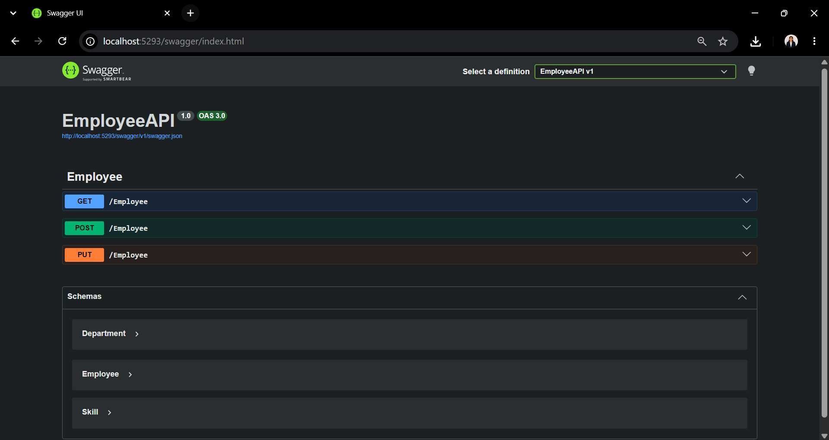
Fig 1: Swagger UI displaying the EmployeeAPI endpoints (GET, POST, and PUT) along with the Employee, Department, and Skill schemas.

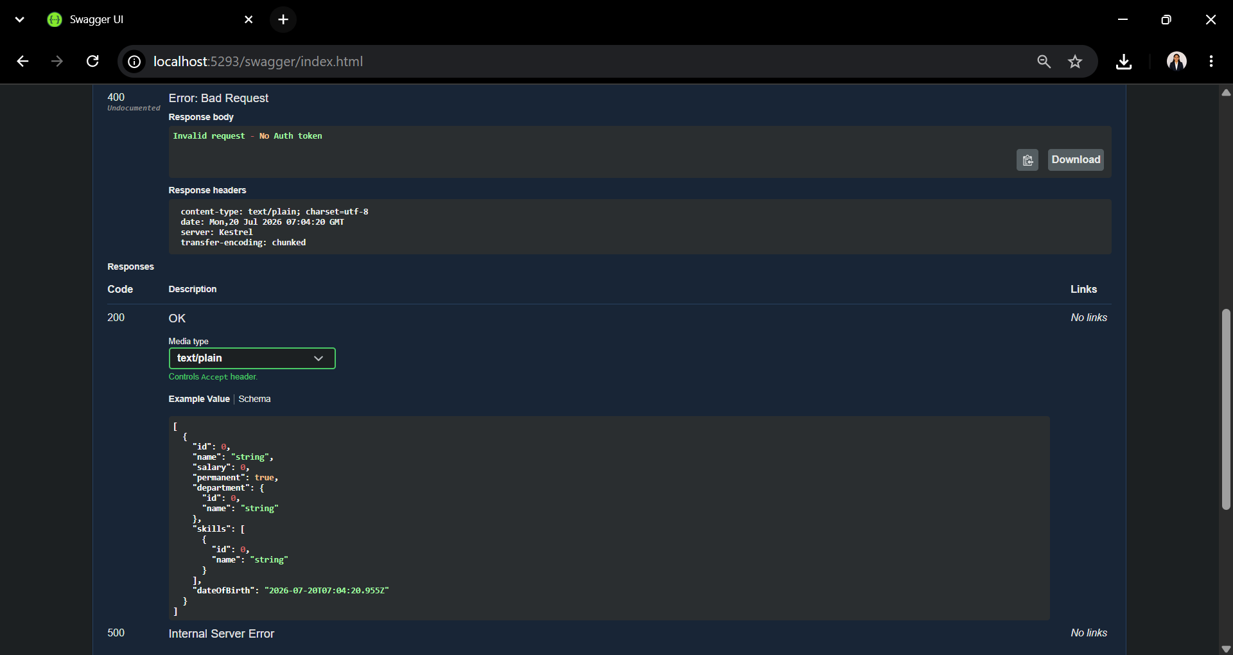
Fig. 2: Swagger UI displaying the GET /Employee API response with 400 Bad Request due to a missing Authorization header, demonstrating the Custom Authorization Filter.
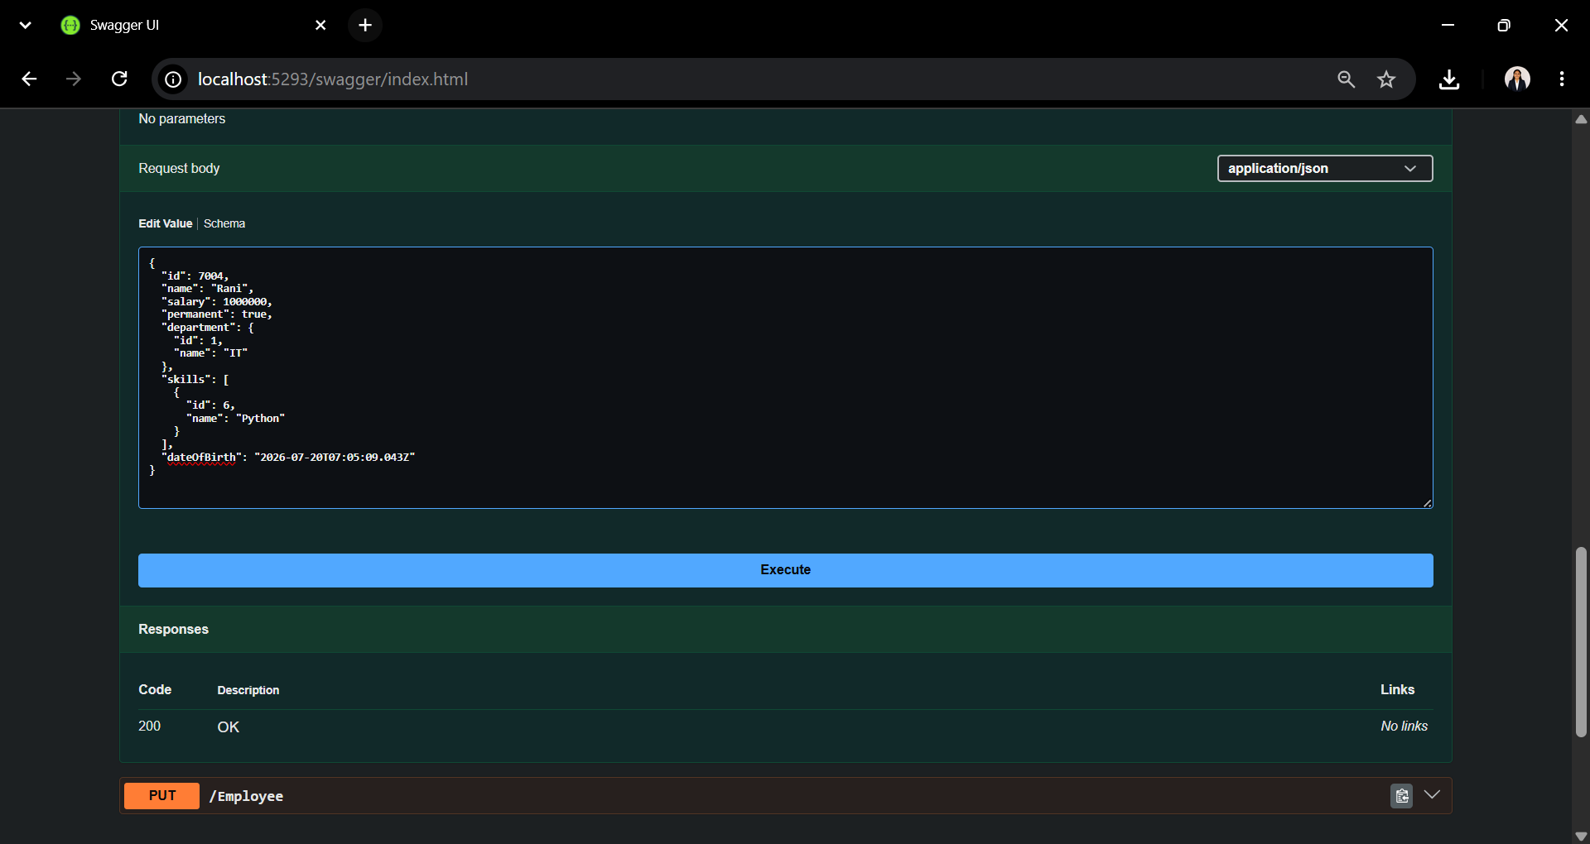
Fig. 3: Swagger UI showing the POST /Employee request with JSON data in the request body using the [FromBody] attribute.

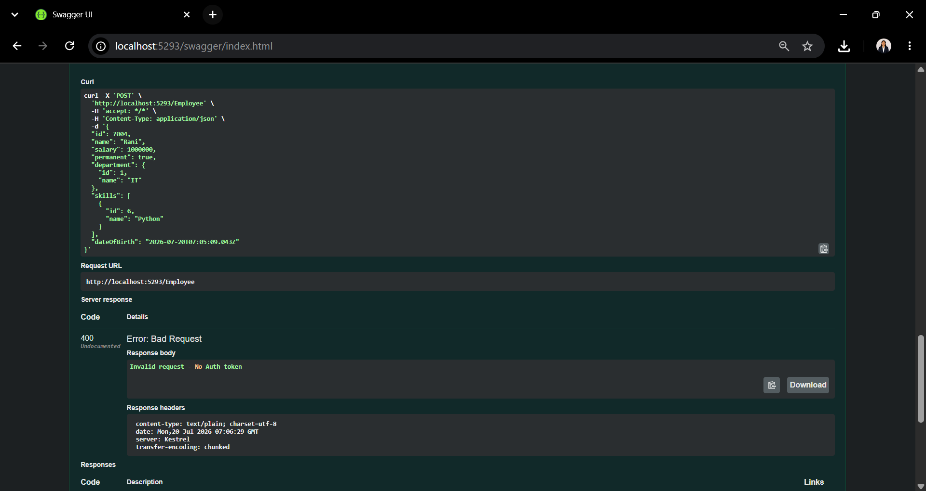
Fig. 4: POST /Employee response showing 400 Bad Request – "Invalid request - No Auth token" generated by the Custom Authorization Filter.
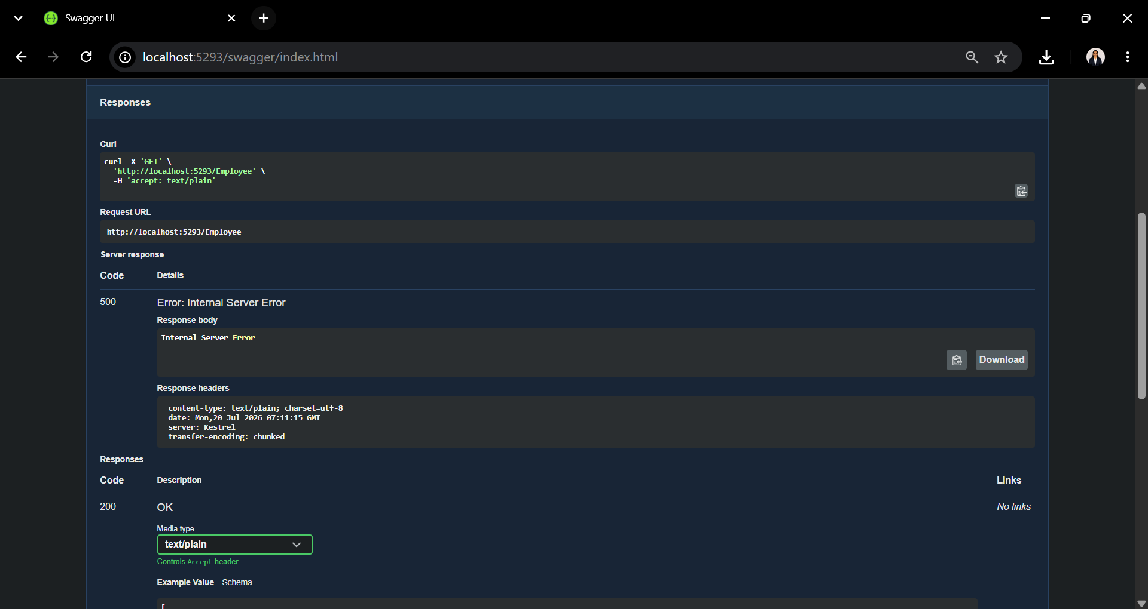
Fig. 5: Swagger UI displaying the GET /Employee API response with 500 Internal Server Error, demonstrating the working of the Custom Exception Filter.

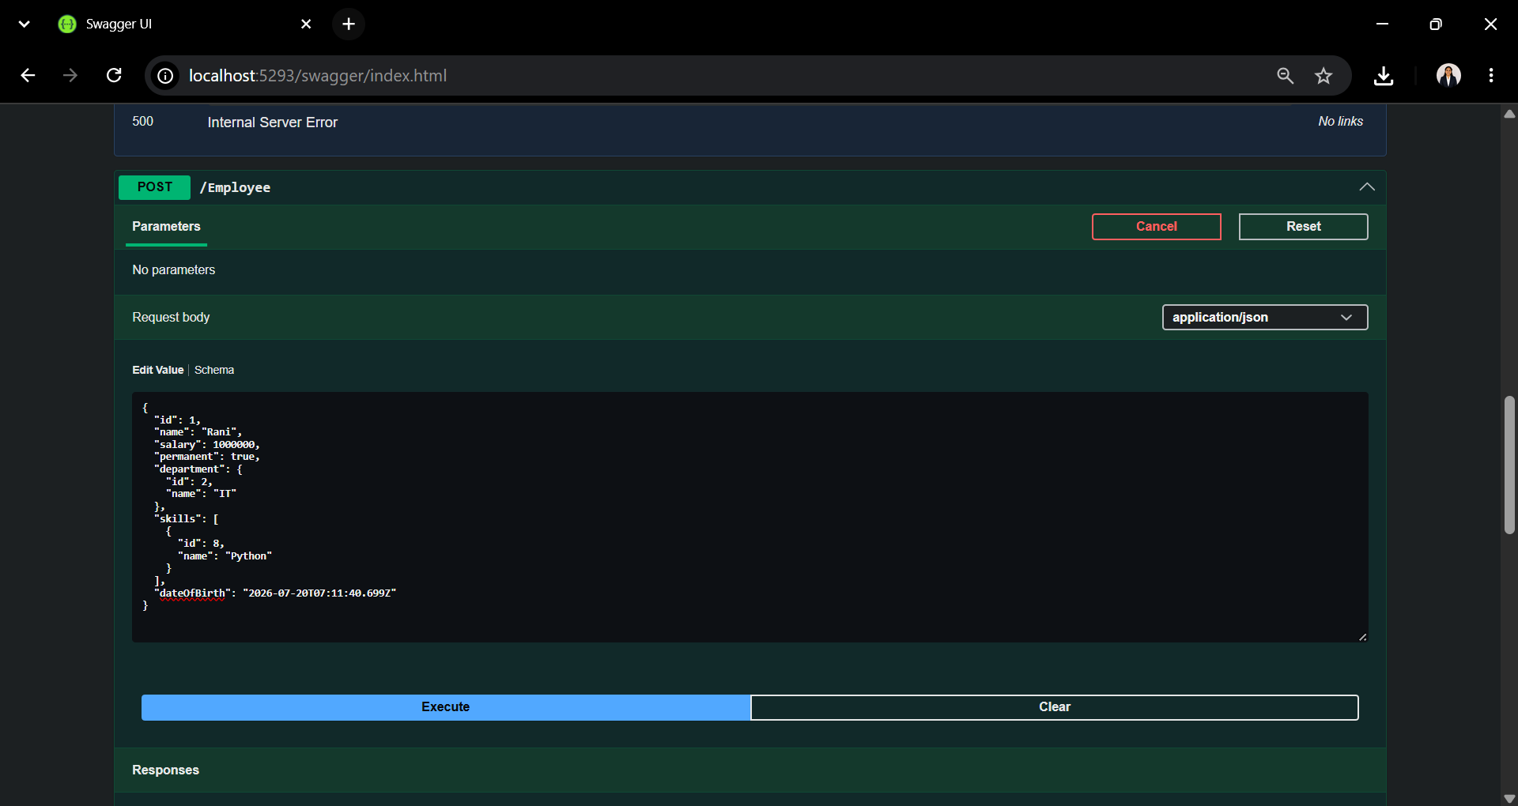
Fig. 6: Swagger UI showing the POST /Employee API request with employee details provided in JSON format through the request body using the [FromBody] attribute.

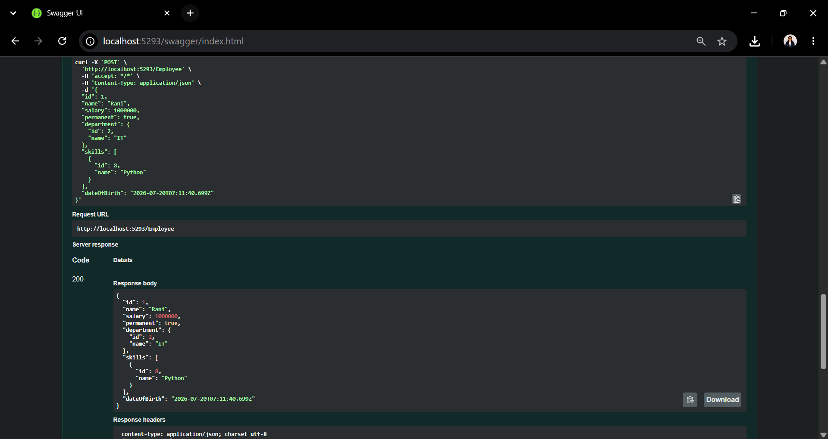
Fig. 7: Successful POST /Employee API response (200 OK) showing the created employee details returned by the Web API.

